First I made nav.js page and it had import {link } form react-router-dom  
then nav function had all links link to ‘/add’ means localhost:5000/add

Its just name of the page

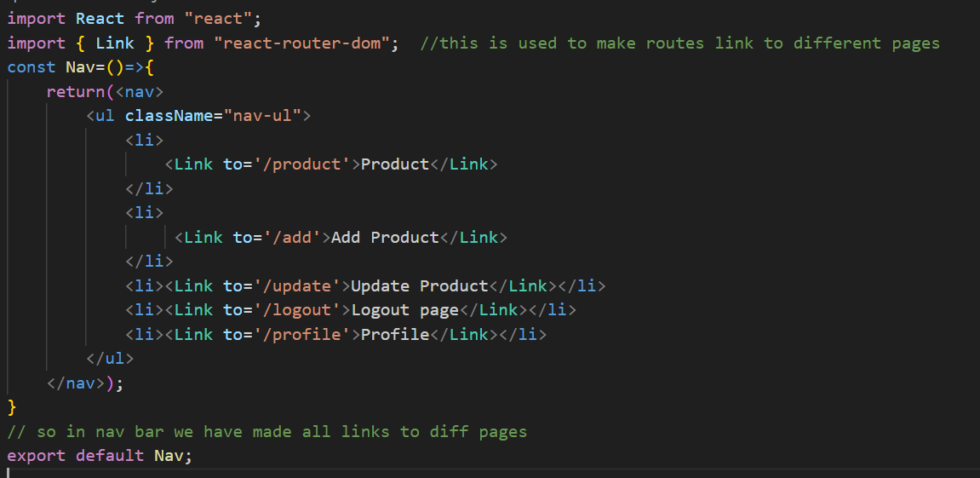

App.js is main folder so inside it I took nav import nav form ./nav  
and also footer and also imported browserRouter like this is required for routing and also import routes and route from react router dom

Then in each route I passed path like localhost:5000/product

And added element for now a simple h1 tag  
nav and footer in browserRouter needs to be inside <BrowserRouter   
  
$$ all Nav Footer must start from capital letter otherwise error is shown even if file name is small the import Nav must be capital

import './App.css';

import Nav from './components/Nav';

import Footer from './components/footer';

import { BrowserRouter, Routes,Route } from 'react-router-dom'; //we need to write nav in this cuz all links are in nav

function App() {

  return (

    <div className="App">

      <BrowserRouter>

      <Nav/>

      <Routes>

        <Route path='/product' element={<h1>This is Product PAGE</h1>} />

        <Route path='/add' element={<h1>This is Add Product PAGE</h1>} />

        <Route path='/update' element={<h1>This is Update PAGE</h1>} />

        <Route path='/logout' element={<h1>This is Logout PAGE</h1>} />

        <Route path='/profile' element={<h1>This is Profie PAGE</h1>} />

        <Route path='/' element={<h1>Home page</h1>} />

      </Routes>

      </BrowserRouter>

      <Footer/>

    </div>

  );

}

export default App;

made a signup page with html css  
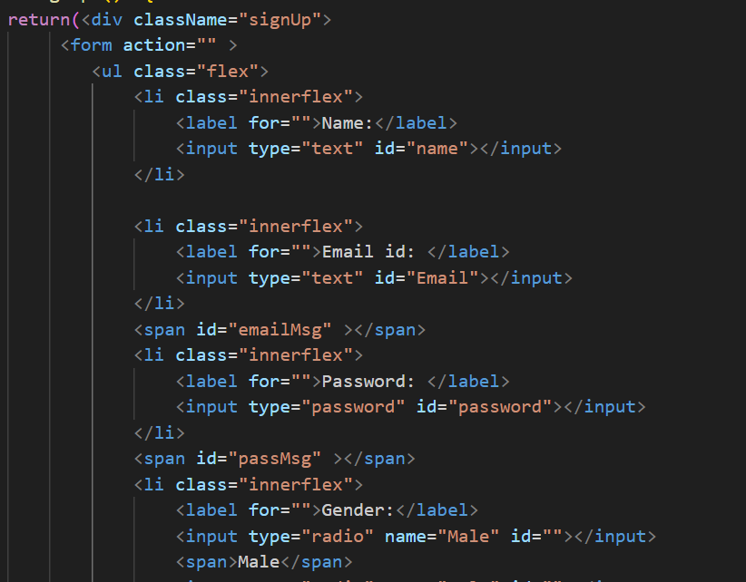

TO store values of name email pass imported useState form react

in signup page where I want to store vars

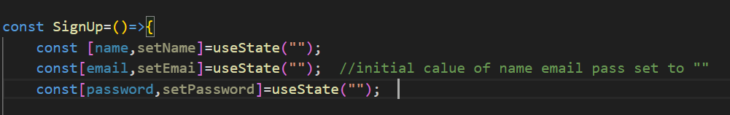

Made these variables with state and setName is a function to set value to name ig

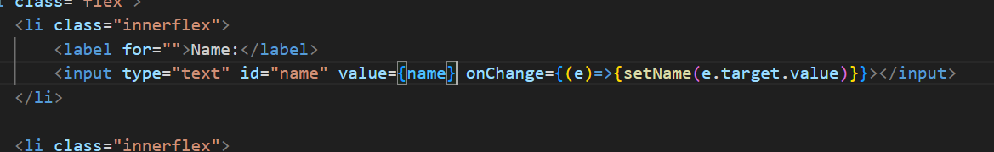

In input set initial value to name which was=”” like whenever website is refreshed the initial name is set to this input field which is blank then user can enter his name

And onchange means when the input field changes an event e occours if u log this it will give a large output but we are just interested in the value so we write target.value and we setName(e.target.value) so now name=”Ashish” whatever the user inputs

Similar with email and pass



BACKEND:

Made simple connection using mongoose

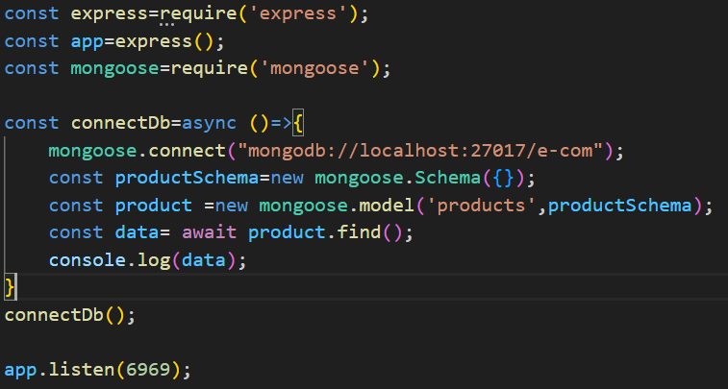

made a db file to store all db related stuff  
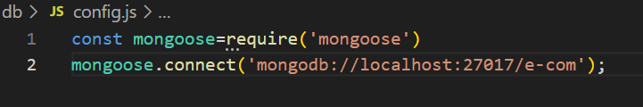  
made a config file to store the connection to the db ecom

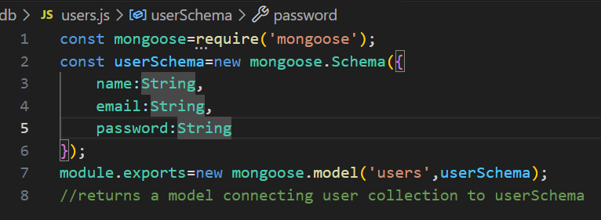

Made a user schema file which exports a model connecting the userschema to user collection which can be stored In an object and used

Imported all this in index.js

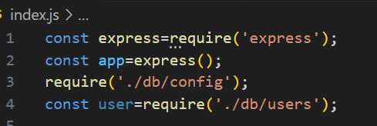

Made a simple api to fetch data from postman and store it in db

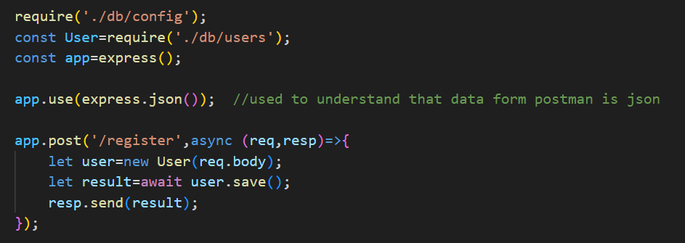

Called a fetch function to call our api copied the post link from postman and pasted it in url of fetch wrote function fetch in onsubmit button

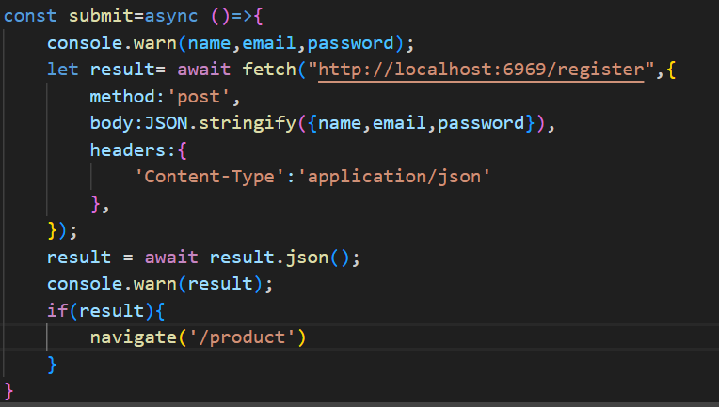

The submit was made an asyn function cuz inside it in fetch function we used await fetch function is like an inbuilt api in js to use apis of backend  
2 parameters of fetch(“url from postman”,

{

method:’post’/’get’/’put’,

Body:{}

Headers:{

‘Content-Type’:’application/json’}

})

In 2nd parameter there is method then body like how u used body in postman but here u need to specify that u are passing data in json form because in api we are accepting data in json form app.use(express.json())

So we write body:JSON.stringify({name,email,pass})

And header:{} is always fixed

Then if the user sign ups we redirect him to home page for that we use useNavigate from react router dom

import {useNavigate} from "react-router-dom"

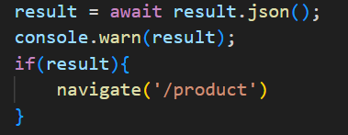

At the end we have restored the value of result in itself because it returns some promise or etc so we have written result.json to convert result in json form and then we have logged result

NOW to make a function that when user is not signed in the website will not allow to access other sections and when user is logged instead of signup logout button will appear

First we make components private like we make all other components which cant be used if the user is not logged in private for that we make a component file PrivateComponent.js

And inside it:

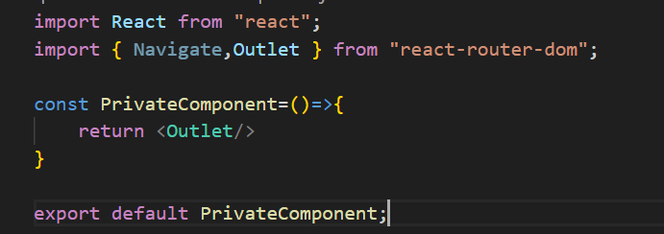

Now in app.js we import this and make a route for element privateComponent and add all other links except signup in this route

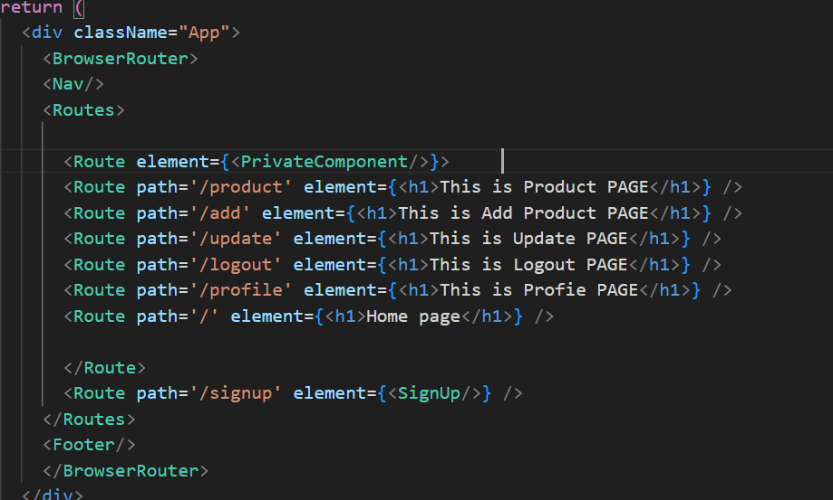

Now we check if there is data in localstorage (we had stored data In localstorage as soon as user sign in with one line)

For that we make a const auth in privatecomp

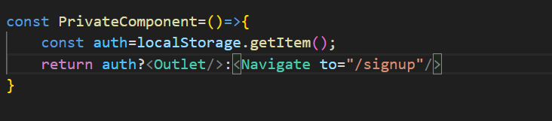

Used a turnery operator outlet means return woh other outlets ig

if the user is already signed in we don’t allow him to go to signnup for that we write in first lines of signup component

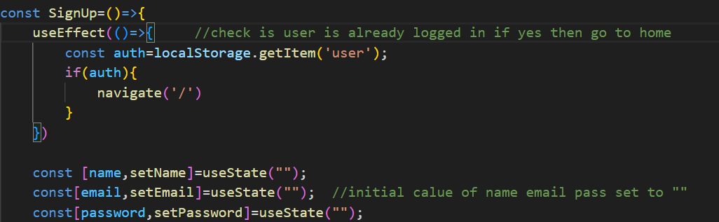

also in nav we checked if auth ie there is user in local storage we show logout button and else we show signup button this is done using turnery

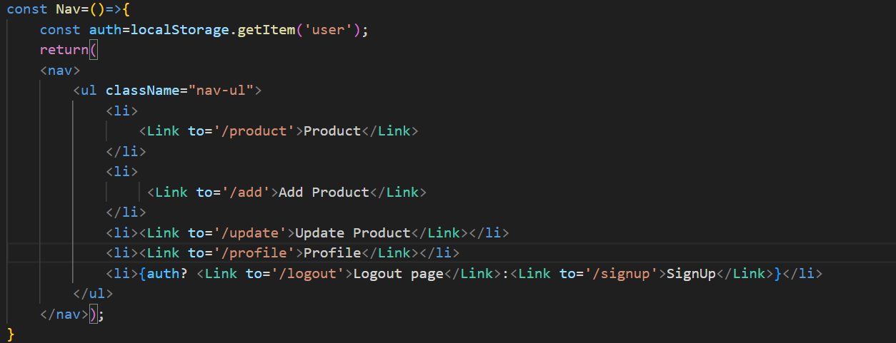

For logout we made a logic

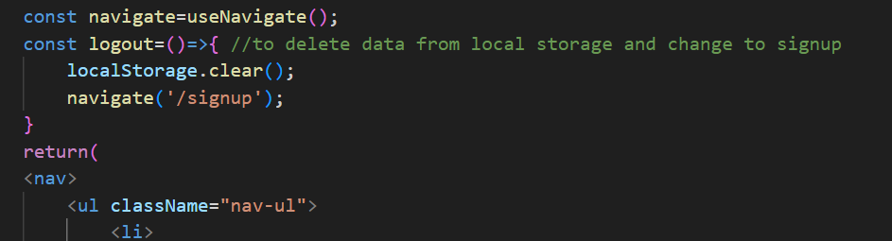

Function logout which deleted from local storage

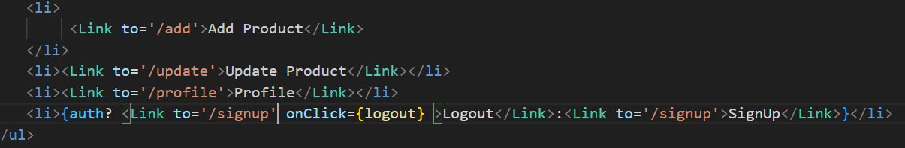

And logout button will be again redirecting to signup page

Like how earlier we had this is logout page onstead of that when user logs put he will again go to signup page

Creating api to check is user exists in db  
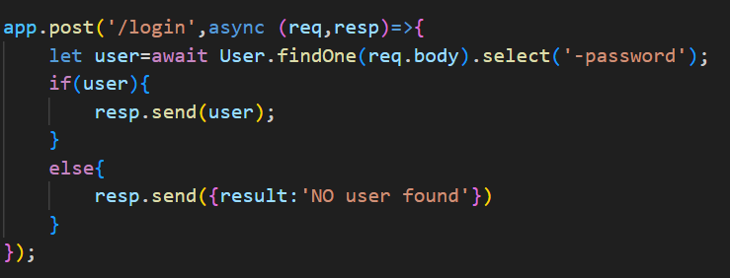this would’ve been the code normally but this works for any one field like in body If I only give email then it will find details and show

If I only give pass it will show but

If I give wrong email and right password or vice versa like if one value is wrong then no data found so for this we just improve this api and say

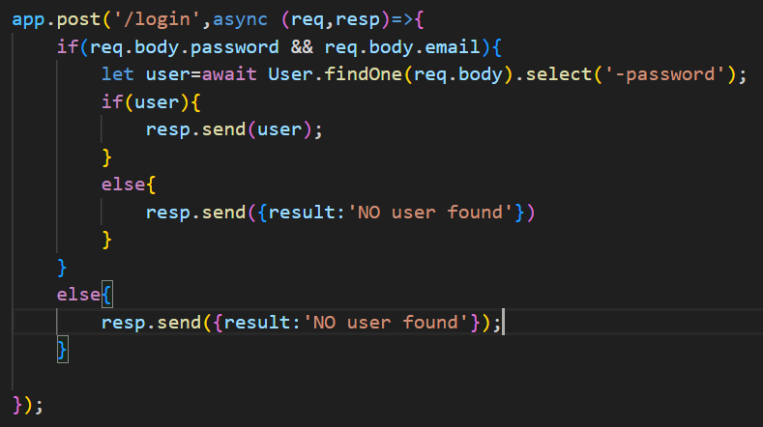

This means if the body has both email and pass then only go ahead or else show no user found

Also a minor modification in the register signup api to hide the password which was logged in the console

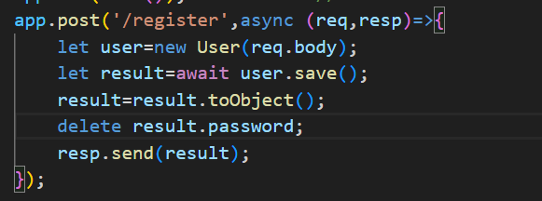

Created a login page

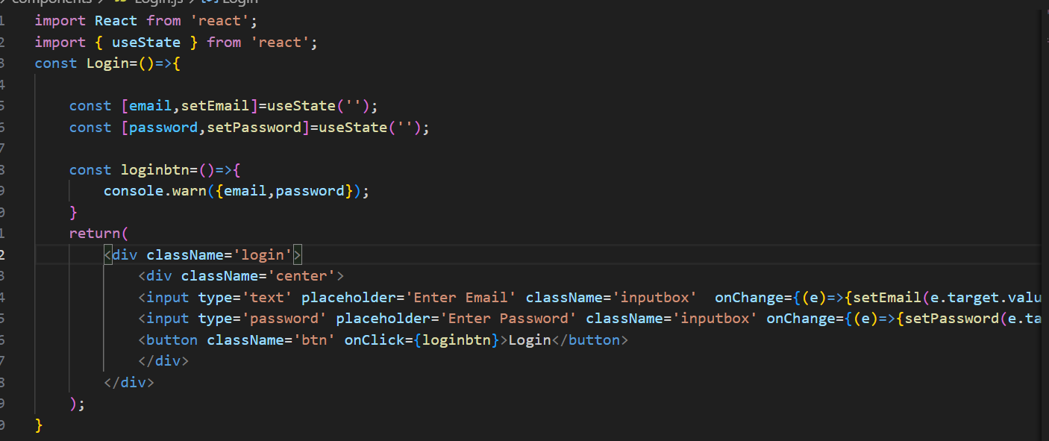

Then integrated it with api

Fetch is used and becsuase fetch returns a promise we write await before it

Api for login:

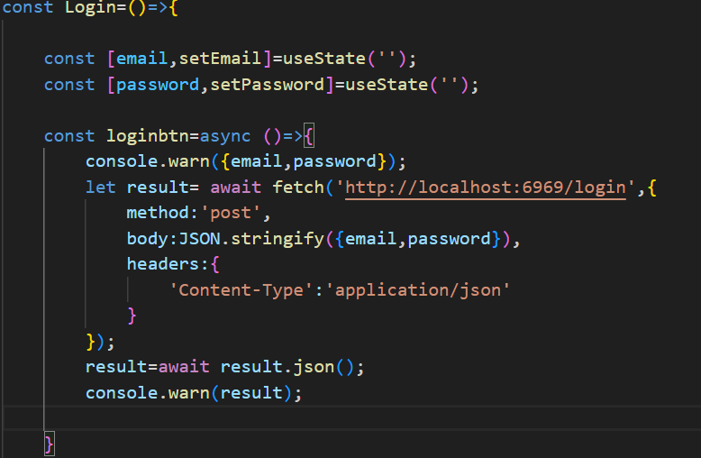

After this if the result is having name like If data exists in db result will have name email and pass but if not then result will be a string having no user found

So to redirect and check if user has entered correct email pass and if not then to notify him to enter valid password:

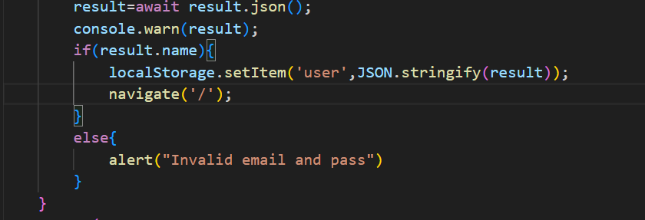

Now if user is logged in he should not see login and sign up page

Only logout button for this we update code in nav now we have to write a single condition that is auth exists ie there is data in localstorage then we show logout button else we show both signup and login button  
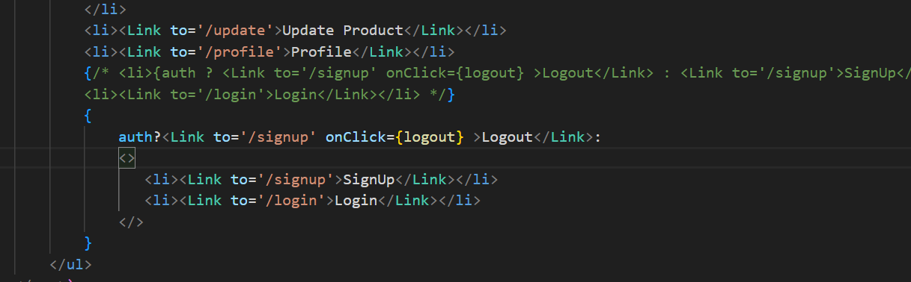  
commented one is old and to write new logic we write it in block{} and also we cant give both li in one : condition so we have to write <></> and inside this we can write both li this is known as fragmenration

Now both buttons will be hidden after user logs in or signs up but what is the user tries to access login page thru link locakhost:3000/login

The login page will open to solve this in the login component we write the first condition to check if there is data in local storage and if yes means user is logged In and he will be directed to homepage

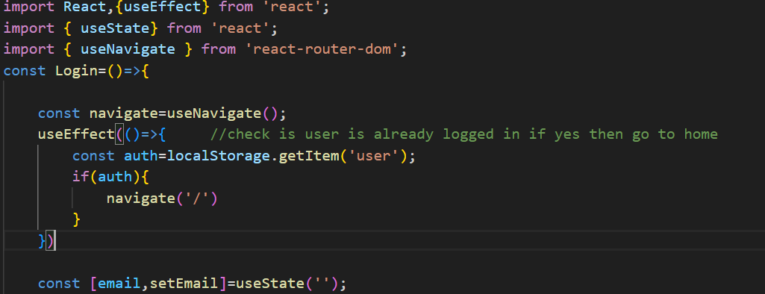

We did the same thing with signup component

Changes made in nav  
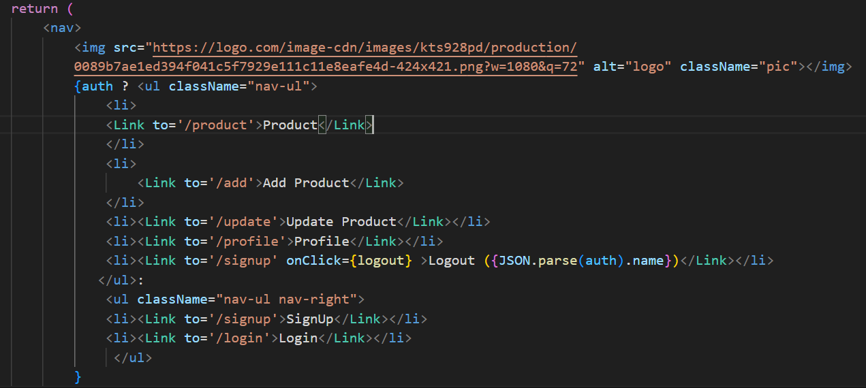

Added logo and changed auth logic  
ie if auth is there means if user is logged in then show other links and if he is logged out then just show sign in and login

And to show the username we have used auth and since it is in json form we parse auth and access its name property

Made an addproducts page where the details of product are fetched and who is adding this products is fetched from the localstorage user id of the current logged in user  
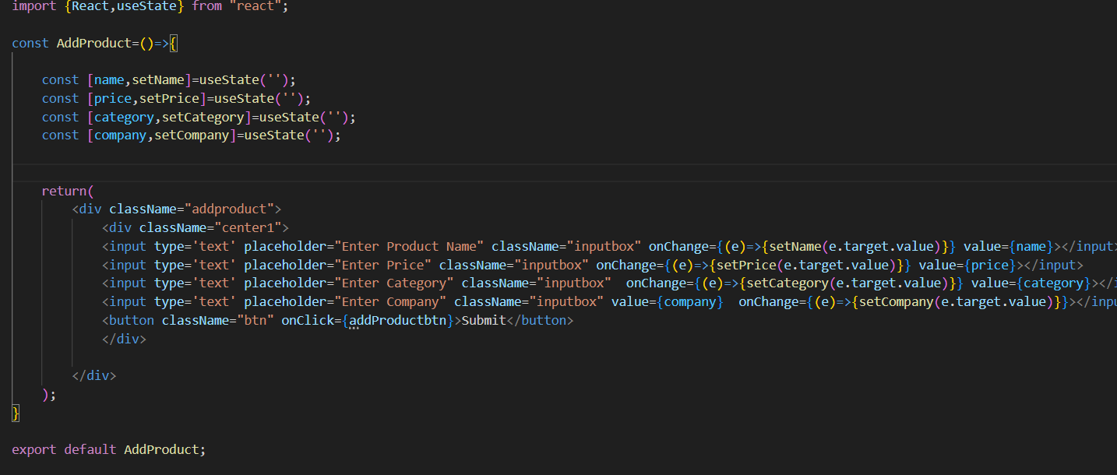

Made an api to store data in products section

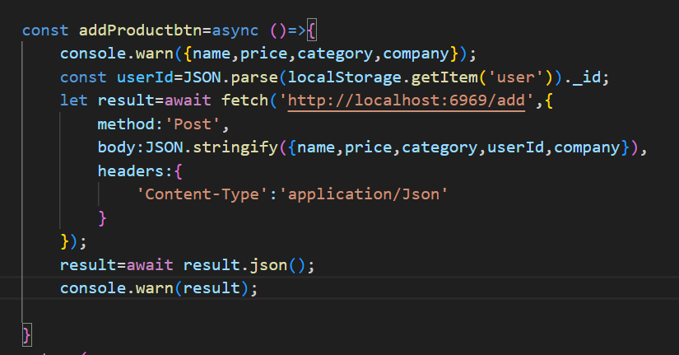

Note that first when I had named userId as userid all other details were saved in mongo db but userid was not saved so I had to change the name and keep it as it was defined in schema like userId

So these things matter

Made simple valiadations for adding prodct that if one field is empty prodct will not be added in mongo db  
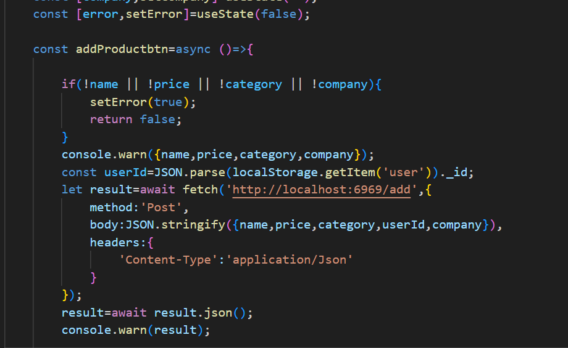

If func returns false then ahead steps will not run that means when u click submit the code checks if all inputs are filled if they are not then it sets error to true and returns

And if error is true

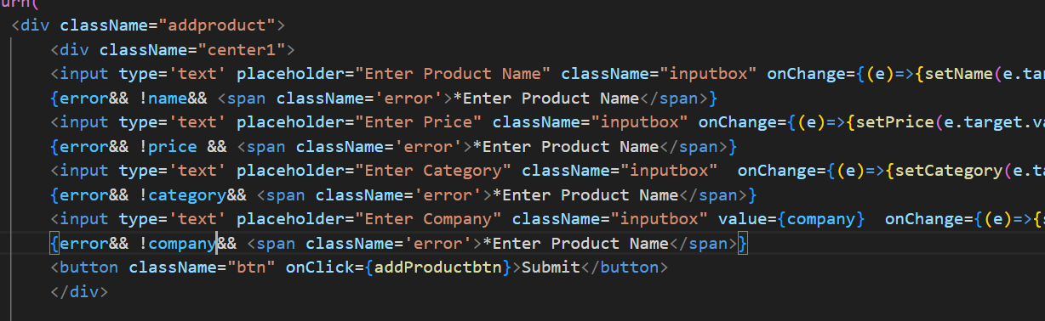

If error is true then error message will be shown

But if name is not added and company and other fields are added then it wont be useful to even show enter valid company name so for that we check error && !name means if name is empty only then show error message and only !name !company cant be written directly without error variable because if u do so then as soon as u load the page all fields are empty then the error will start showing as soon as the page loads so to avoid this we have added error which is initially false so no span msgs are displayed

But when the user clicks the submit button only then error is set to be true and then the error msg is shown

Made a basic api to find products  
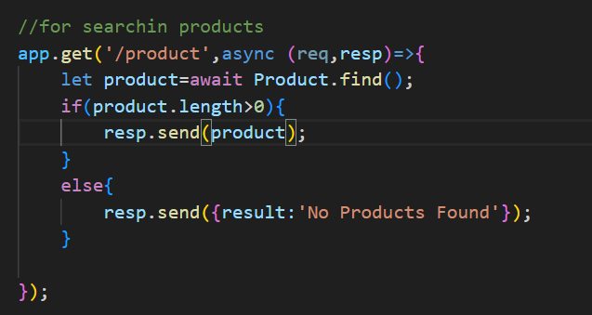

Frontend:

To show products we make an array to be precise it will be an array of objects which will store all the rows from mongo inside it.so In use state we write [] unlike (‘’) because products is an array.

Get product api  
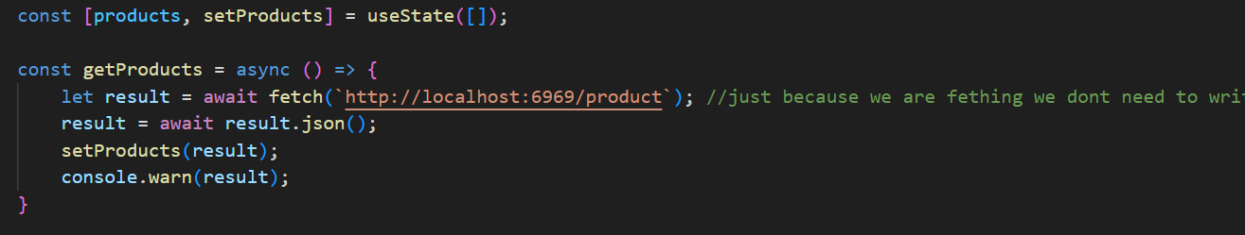

This api in fetch we just give url because we don’t have to pass anything in the body and after we fetch everything in the result we make it into json and then we do setProducts(result) this means we are storing the data in the result variable into prouct variable so we can use product variable to display the data in mongo db  
now product has all data from mongodb

 <h1>Products</h1>

            <table border={1} cellPadding={20} cellSpacing={3} className="tablestyle">

                <thead>

                    <th>Sr no.</th>

                    <th >Name</th>

                    <th>Price</th>

                    <th>Category</th>

                    <th>Company</th>

                    <th colSpan={2}>UserID</th>

                    <th>Operation</th>

                </thead>

                { products.map((item,index)=>

                    <tbody>

                    <tr><td>{index+1}</td>

                    <td>{item.name}</td>

                    <td>{item.price}</td>

                    <td>{item.category}</td>

                    <td>{item.company}</td>

                    <td colSpan={2}>{item.userId}</td>

                    <td align="center"><button className="deletebtn" onClick={()=>deletebtn(item._id)}>Delete</button></td>

                    </tr>

                    </tbody>

                    )}

            </table>

        </div>

Now see we are showing data in table main thing to focus is that how we are accessing products variable

Products is an array so it has functions so products has map function

So map does is it iterates through the array and like map has an argument arrow function map((item,index)=>)

Now after => we are not usning {} because it is already structured cuz we are using <tbody>and this products.map needs to be used in a block {

}

As u can see

And each item is like an object like a row of data in mongo so row has all cols .name .categoty

Which can be used by . operator

I made a delete api and did many silly mistakes   
1] use route delete app.delete

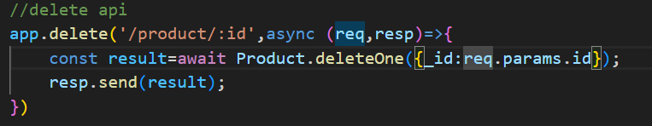

And use delete one and specify acc to which col u have to delete like

Deleteone({name:’Ashish’}) etc don’t directly write delete one(req.params) or req.params.id

I wrote that and deleted the entire db

Also do resp.send() only once if u do it agin and again it makes problems

And id in mongo db is _id so don’t forget underscore

Frontend



The function called is ()=>delete(item._id)

U cant directly write onclick={delete(item._id)} it gives error u have to define this way its syntax

And like in displaying product we made a variable item item has all attributes that are there in mongodb database so for that we can write item._id

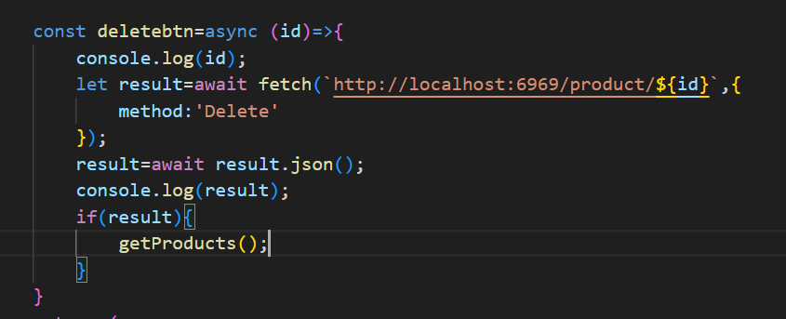

And important point in fetch the url must be written under `` the symbol beside 1 button not between ’’ like we write usually because thr ${} does not work under ‘’

And we are using get products again because getproducts function gets the data of products fom the database  
so if we don’t write get product even when we delete the data it dosent go we have to refresh then the row goes

So to avoid this we write get products like we did in useffect

Use effect is used like the first action to do when page is refreshed so whenever page is refreshed we getdata fron mongo

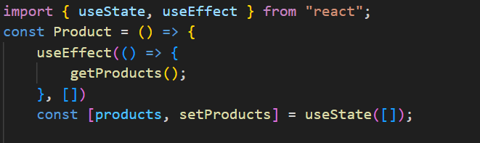

And second parameter has to be [] of use effect

Added update button in table which redirects to update [page and

also has id in query for that we made changes in app.js

Cuz in app we had route for /update but if we searched

/update 6adjk234uk33h then the page dosent know where to be redirected

So fot that we added /update/:id

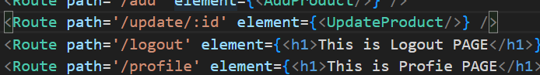

And made update page same as add product page

Now when user clicks on update from product he should be redirected to update page and where all input fields should be automatically filled with the current details of the product for this we use the get api   
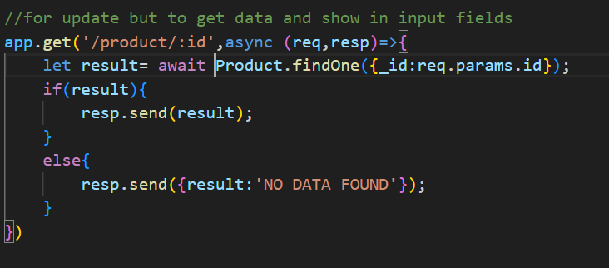

Now in frontend

We include params to use params

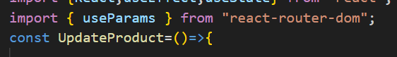

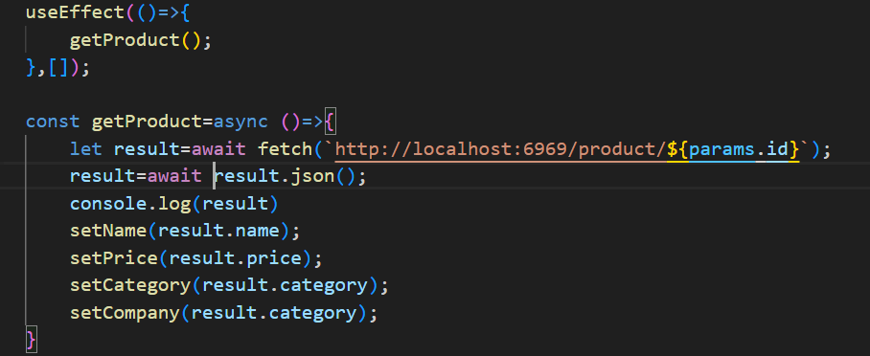

And when page refresh by use effect we call get api and we pass id of selected object thry parameters using params and for this we don’t use ‘’ we use `` then we set all values to values fetched from db

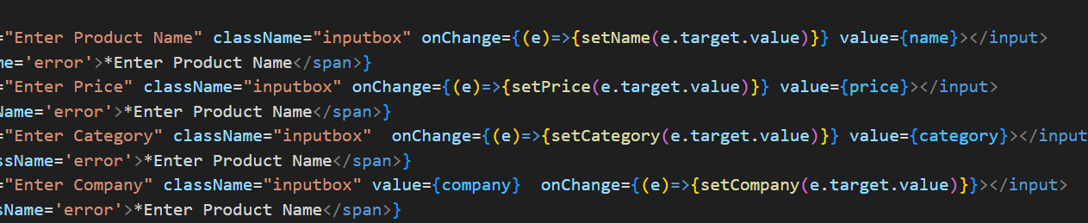  
and since all values of input fields were set to respective vars they are automatically update

Made update product api and tested it on postman:

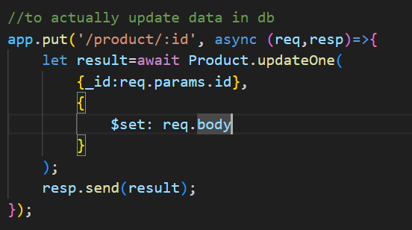

Made frontend fetch api for update product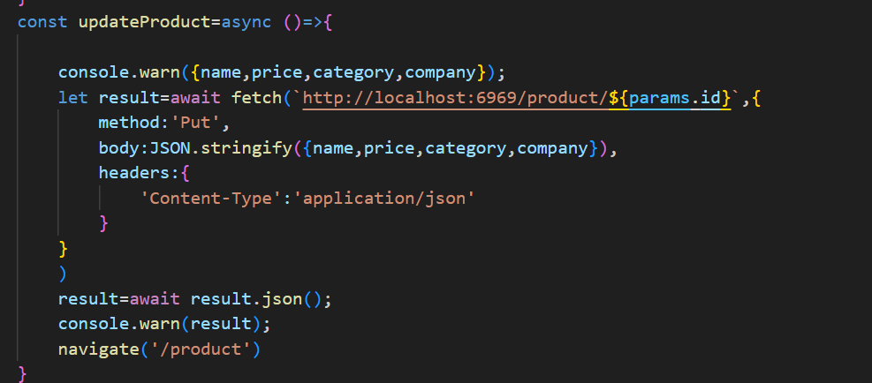

Notice that we used backticks `` because we had to use ${}

And after product is updated we redirect to product page

Made search api:

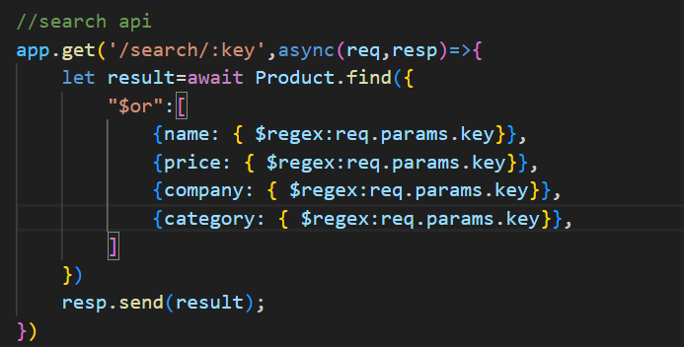

The search api will be get route   
and the find method usually takes an object find({name:Ashish})

Or name :req.params.name

But here we want to search by multiple fields in db so we use   
“$or”:[] which is an array and inside it we write objects {}

Which we could write in find({})

Now if we direcly write name:req.params.id even if we enter te it will not show output tea we exactly have to put TEA to get output so to solve this we use REGEX as shown in the pic with its syntax

Frontend: added a search field in produsts   
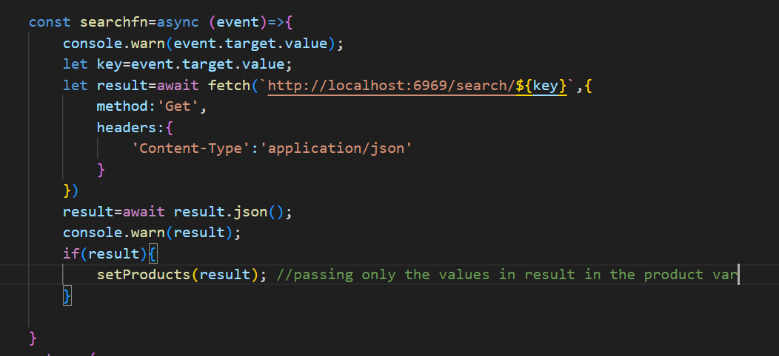  
this is api to get from search api then store result of search in result

After this we setproducts to result  
like id u remember in getproducts funtion we get list of all products form our database and do setproduct(result)

Here setprocuct is not a function it is like usestate

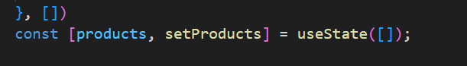

So we set setproduct to result only showing the products that got into result array after search api was called

But this had a problem If u searched an element and found then just erased everything from search again all ele were not displayed  
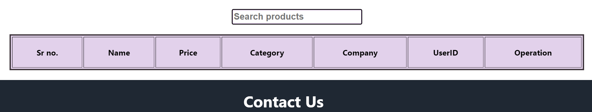

To solve this we check if length of event.target.value

If its greater than 0 then call search otherwise no  
